
NED UNIVERSITY OF ENGINEERING AND TECHNOLOGY

COURSE TITLE AND CODE:
TECHNOLOGY MANAGEMENT (MG-212)

PROJECT
TECHNOLOGY STRATEGY REPORT

Group Members:
Nabeed Jamshed (SE-23054)
Talha Hussain (SE-23062)
Tooba Fayyaz (SE-23071)
Muzammil Butt (SE-23103)
Laiba Majeed (SE-23302)

Course Instructor:
Dr. Erum Abbas
Contents
Technology Management Plan for Sui Southern Gas Company (SSGC) 3
1. Company Overview: 3
2. Environmental & Capability Assessment: 4
2.1 SWOT Analysis 4
2.2 Technology Capability Assessment 5
2.3 Key External Drivers 5
3. Technology Strategy Proposal: 5
3.1 Proposed Technology and Strategic Role 5
3.2 Implementation Roadmap 6
3.3 Technology Portfolio & S-Curve Mapping 7
4. Risk, Ethics, and IP Considerations: 9
4.1 Potential Risks 9
4.2 Ethical Considerations 9
4.3 IP Considerations 9
5. Expected Outcomes & Impact: 9

Technology Management Plan for Sui Southern Gas Company (SSGC)

1. Company Overview:
Organization Description
Sui Southern Gas Company (SSGC) is one of Pakistan’s largest state-owned public sector utility organizations responsible for the transmission and distribution of natural gas across Sindh and Balochistan. As a large government enterprise, SSGC plays a critical national role in ensuring uninterrupted natural gas supply to residential, commercial, and industrial sectors. The company maintains an extensive pipeline network, multiple transmission lines, distribution grids, and compression stations that support continuous gas delivery throughout the southern region of the country. Its operations rely heavily on the Supervisory Control and Data Acquisition (SCADA) system, which provides centralized monitoring of gas pressure, flow rates, and network stability.
Despite possessing real-time monitoring capabilities through SCADA, several key operational processes still depend on manual intervention. Daily gas inflow and outflow readings, station performance data, and maintenance logs are frequently collected and verified manually by field personnel. This introduces inefficiencies, human error, and delays in reporting. The absence of integrated predictive analytics limits the organization’s ability to forecast gas demand, anticipate shortages, or optimize supply schedules during unplanned events such as pipeline leaks, pressure drops, or maintenance shutdowns.
To address these challenges, the proposed project focuses on implementing an AI-powered forecasting and automation solution that enhances gas demand prediction, inventory planning, and predictive maintenance. By leveraging historical records and real-time data from SCADA, the solution aims to transition SSGC toward fully data-driven operations with improved efficiency, accuracy, and reliability.
SSGC faces a growing need for automation and intelligence-driven planning due to increasing demand fluctuations, aging infrastructure, and expanding consumer bases. The company’s current challenge lies not in the shortage of data but in the lack of modern tools to convert operational data into actionable insights. As a result, the organization struggles with inefficient resource planning, lack of proactive decision-making, and delayed responses to network abnormalities.
Site Visit and Observations
As part of the project, the team conducted an on-site visit to SSGC facilities to observe operations, workflows, and data management practices firsthand. During the visit, the team analyzed the following:
- Manual data collection procedures at gas stations and control rooms.
- Usage of the SCADA system for monitoring gas flow, pressure, and network stability.
- Maintenance operations and preventive maintenance scheduling.
- Staff interactions with existing digital tools and areas where automation could improve efficiency.
- Infrastructure layout, including pipeline networks, compression stations, and distribution grids.
The site visit helped validate operational challenges such as dependency on senior staff, delayed reporting due to manual processes, and limited use of predictive analytics. These observations informed the proposed AI-powered forecasting and automation solution and helped develop practical recommendations aligned with SSGC’s current capabilities and constraints.

Environmental & Capability Assessment:

2.1 SWOT Analysis
Strengths and Weaknesses
Strengths | Weaknesses
Sole Provider of Gas Supply: Stable consumer base and revenue stream | Manual Data Collection: Prone to human error
SCADA-Based Automation System: Real-time monitoring and control | No Predictive Analytics: Delayed responses to demand fluctuations
Experienced Workforce: Strong technical knowledge | Dependence on Senior Staff: Operational risks if key employees unavailable
Established Infrastructure: Extensive pipelines, compression stations, distribution grids | Limited Technical Expertise: Workforce lacks experience in data analytics, IoT, automation
Government Support and Stability: Financial and administrative backing
Well-Maintained Data Records: Historical records for analytics and forecasting
Opportunities and Threats
Opportunities | Threats
Adoption of IoT-Based Monitoring Systems: Automate data collection | Cybersecurity Risks: Exposure to hacking and data breaches
Predictive Forecasting and Simulation Tools: Optimize supply chain performance | System Transition Challenges: Data loss or compatibility issues
Development of a Centralized Digital Dashboard: Instant monitoring and alerts | Employee Resistance: Unfamiliarity or fear of automation
Government Digital Transformation Initiatives: Funding and policy support | Vendor Dependency: Reliance on third-party vendors for maintenance
Workforce Upskilling: Training in analytics and automation | Time Required for AI Model Training: Delays in realizing predictive benefits
SWOT Matrix Summary
- Strengths: SCADA system, sole provider, experienced staff, government support, well-maintained data.
- Weaknesses: Manual work, limited trained staff, reliance on key personnel, no forecasting.
- Opportunities: Integrate predictive forecasting systems, workforce upskilling, centralized dashboards, government support.
- Threats: Security risks, employee resistance, vendor dependency, time to train AI models.

2.2 Technology Capability Assessment
- Current Infrastructure: SSGC currently uses SCADA, distributed sensors, and centralized control rooms. Data is underutilized and not integrated into AI systems.
- Operational Skills: The workforce is technically strong in mechanical and electrical domains but lacks expertise in machine learning, predictive analytics, data engineering, and automation frameworks.
- Readiness Level: The organization is at a mid-level technology readiness, capable of implementing AI but requiring workforce training and system upgrades.

2.3 Key External Drivers
- Regulations: Government focus on transparency, energy conservation, and digital transformation encourages modernization.
- Energy Demand Trends: Seasonal fluctuations, industrial expansion, and household consumption patterns require advanced forecasting tools.
- Technological Shifts: Global gas utilities adopting IoT, AI dashboards, and automation increase pressure on SSGC.
- Economic Conditions: Rising operational costs demand more efficient planning methods.
- Technology Strategy Proposal:

3.1 Proposed Technology and Strategic Role
Proposed Technology:
Hybrid Automation and AI-Based Forecasting System integrating:
- Gas Inflow/Outflow Forecasting
- Inventory Forecasting for Gas Supply Planning
- Predictive Maintenance Algorithms
- Automated Dashboards for SCADA
- Automated Reporting and Excel Sheet Generation
- Human-in-the-Loop Decision Support
The system uses machine learning models trained on historical SCADA data, field reports, and maintenance logs to deliver accurate predictions and automated insights.
Strategic Role of Technology:
- Operational Efficiency: Automation reduces manual workload and improves real-time visibility.
- Cost Reduction: Predictive maintenance minimizes breakdowns and optimizes repair schedules.
- Data-Driven Decision Making: Forecasting enables proactive planning.
- Service Reliability: Accurate demand prediction ensures consistent gas supply.
- Innovation Leadership: Positions SSGC as a modern utility provider.

3.2 Implementation Roadmap
Short-Term (0–6 Months)
- Digitize manual data-entry processes
- Conduct AI and analytics training workshops
- Clean and classify historical SCADA and maintenance data
- Build initial dashboards displaying real-time metrics
- Begin pilot forecasting models for inflow/outflow prediction
Mid-Term (6–18 Months)
- Fully integrate AI forecasting models into SCADA
- Deploy predictive maintenance engine
- Implement smart alerts for pressure drops, leaks, and anomalies
- Launch automated daily/weekly reports and Excel sheet generation
- Create centralized cloud-based decision-support dashboard
Long-Term (18–36 Months)
- Expand forecasting models to seasonal trends
- Integrate IoT sensors for remote monitoring
- Automate field operations through mobile data capture
- Develop long-term strategic planning simulations using AI
- Move toward fully self-adjusting hybrid automation system

3.3 Technology Portfolio & S-Curve Mapping
Technology Portfolio
The project focuses on AI-powered forecasting and automation for SSGC. The technologies included in the portfolio are:
- AI Forecasting Models – Predict future gas inflow/outflow and optimize inventory planning.
- Predictive Maintenance Algorithms – Reduce unplanned equipment failures and extend asset life.
- IoT Sensor Integration – Real-time remote monitoring of network pressure, flow, and leaks.
- Dashboards & Reporting Tools – Automated dashboards for SCADA integration and decision support.
Technology Component | Strategic Role | Current Maturity | Strategic Importance | Notes
IoT Sensors (Smart Meters) | Emerging | Low-Medium | High | Planned deployment to enhance real-time monitoring of gas flow and consumption
AI-based Forecasting Models | Emerging | Low | High | Uses historical SCADA and field data for accurate demand prediction
Predictive Maintenance Algorithms | Emerging | Low | Medium | Reduces unplanned breakdowns; depends on sensor and historical data
Automated Dashboards & Reporting | Core/Enhancement | Medium | High | Expanding current dashboards for analytics, visualization, and automated reporting
Human-in-the-loop Decision Support | Core/Enhancement | Medium | Medium | Ensures operator validation of AI-generated recommendations

S-Curve Mapping
The S-curve now reflects technologies that are emerging and will grow in performance over time:
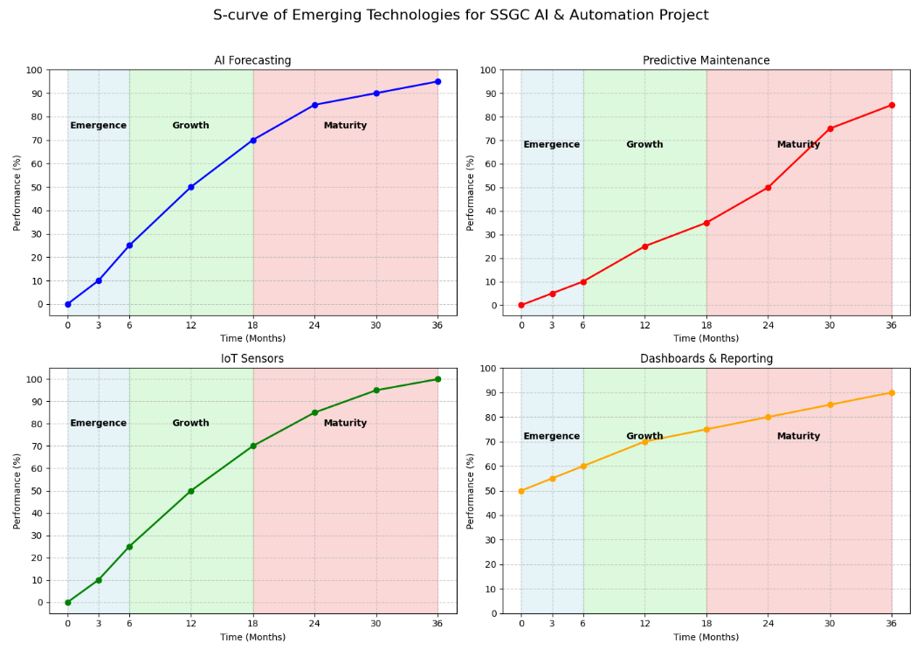
Interpretation:
- AI Forecasting Models: Gradually improve as historical SCADA data is used for training; near full maturity expected in 36 months.
- Predictive Maintenance: Gains performance as IoT sensors are deployed and data accumulates; significant efficiency improvements expected after 30 months.
- IoT Sensors: Deployment will be phased; full integration with AI systems expected around 36 months.
- Dashboards & Reporting: Enhancement of existing dashboards, expanding automation and analytics; will reach full potential within 36 months.
- Human-in-the-loop Decision Support: Improves as AI insights stabilize and operators gain confidence in the system.
Implications for Strategy:
- Investment and focus should be on AI forecasting, predictive maintenance, and IoT deployment, which are currently emerging.
- Existing infrastructure (SCADA) supports these initiatives but is already mature, so it is not tracked on the S-curve.
- Phased implementation ensures data-driven decision making, better operational efficiency, and minimized disruption.

Risk, Ethics, and IP Considerations:

4.1 Potential Risks
- Cybersecurity threats from AI-driven systems
- Workforce resistance to change
- Reluctance to fully rely on automation
- Model inaccuracy risks
- Vendor dependency
- Data migration challenges

4.2 Ethical Considerations
- Ensure transparency of AI decisions
- Maintain strict confidentiality of operational data
- Avoid replacing employees; focus on upskilling
- Ensure fairness and accuracy in predictive algorithms

4.3 IP Considerations
- Protect proprietary AI algorithms and dashboards
- Secure copyrights for automated reports and insights
- Maintain data ownership and confidentiality agreements with vendors
- Expected Outcomes & Impact:
Expected Outcomes
- Improved accuracy in gas inflow and outflow forecasting
- Faster and more efficient reporting through automated dashboards
- Significant reduction in manual data entry and human error
- Better inventory planning through AI-based forecasting
- Fewer unplanned equipment failures due to predictive maintenance
- Lower operational and maintenance costs
- Higher network reliability and fewer supply disruptions
- Improved decision-making with real-time data and alerts
- Increased transparency and accountability in operations
- Enhanced customer satisfaction through consistent service delivery
Key Performance Indicators (KPIs)
  - Operational Efficiency
- Reduction in manual data entry workload by 60–70%
- Decrease in reporting time by 50–70%
- Improvement in forecasting accuracy to 80–90%
  - Service Reliability & Maintenance
- Reduction in unplanned maintenance events by 20–30%
- Increase in system uptime to 95% or higher
- Faster fault detection and response by 40–50%
  - Financial Impact
- 10–15% reduction in operational costs
- 20% reduction in resource wastage
- Improved asset lifecycle by 10–12%
  - Digital Transformation & Adoption
- At least 80% of operational staff trained on dashboards and AI tools
- Organizational adoption rate above 70%
- Integration of 100% SCADA real-time data into forecasting engine

References:
[1] A. Daneels and W. Salter, “Technology Survey Summary of Study Report,” IT-CO/98-08-09, CERN, Geneva, 26th Aug. 1998.
[2] A. Daneels and W. Salter, “Selecting and Evaluation of Commercial SCADA Systems for the Controls of the CERN LHC Experiments,” this Conference.
[3] G. Baribaud et al., “Recommendations for the Use of Fieldbuses at CERN in the LHC Era,” in Proc. 1997 Int. Conf. Accelerator and Large Experimental Physics Control Systems, Beijing, 1997, p. 285.
[4] R. Barillere et al., “Results of the OPC Evaluation done within the JCOP for the Control of the LHC Experiments,” this Conference.
[5] A. Ahmad, “Ethical implications of artificial intelligence in accounting: A framework for responsible AI adoption in multinational corporations in Jordan,” Int. J. Data and Network Science, vol. 8, no. 1, pp. 401–414, 2024.
[6] H. Allioui and Y. Mourdi, “Unleashing the potential of AI: Investigating cutting-edge technologies that are transforming businesses,” Int. J. Comput. Eng. Data Sci., vol. 3, no. 2, pp. 1–12, 2023.
[7] J.A. de Chalendar and S.M. Benson, “A physics-informed data reconciliation framework for real-time electricity and emissions tracking,” Appl. Energy, vol. 304, p. 117761, 2021.
[8] A.R. Hasan, “Artificial Intelligence (AI) in accounting & auditing: A Literature review,” Open J. Bus. Manage., vol. 10, no. 1, pp. 440–465, 2021.
[9] H. Felzmann, E. Fosch-Villaronga, C. Lutz, and A. Tamò-Larrieux, “Towards transparency by design for artificial intelligence,” Science and Engineering Ethics, vol. 26, no. 6, pp. 3333–3361, 2020.
[10] O.T. Gabriel, Data Privacy and Ethical Issues in Collecting Health Care Data Using Artificial Intelligence Among Health Workers, Ph.D. dissertation, Center for Bioethics and Research, 2023.

